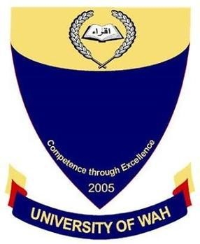
Database Lab
UW-24-CS-BS-101
Registration NO:
Muhammad Talha_CS.2ndB
Mid Sessional
UNIVERSITY OF WAH(UOW)

DEPARTMENT OF COMPUTER
SCIENCE

COURSE:

SUBMITTED BY:

-: Sessional :-
Tables
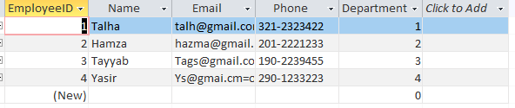
- Employee

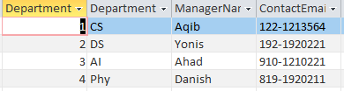
- Department

- Clients

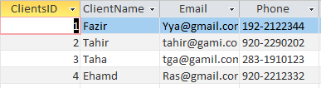

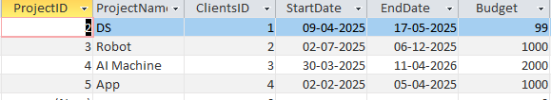
- Projects

- Project Assignment
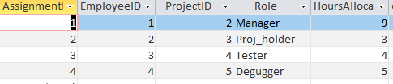

- Payments

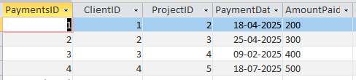
Rules

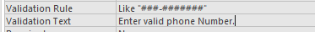
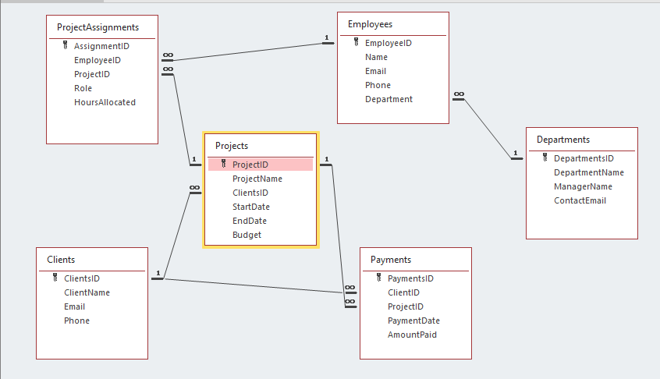
Relationship

Query

